SECURE VOTING SYSTEM WITH AADHAR VERIFICATION THROUGH BLOCKCHAIN
Scope and Limitations
Department of Computer Science and Engineering, TKR College of Engineering & Technology
Batch C1 (CSE-C) · Academic year [ACADEMIC YEAR]
Table 1: Project team
S.No. | Student name | Roll number
1 | Mohammed Anwar-Ul-Haq | 23K91A05F6
2 | Mohammad Mosin | 23K91A05F4
3 | Manda Akshitha | 23K91A05E4
4 | Kothlapur Ganesh | 24K95A0516

Project guide: B Shruthi
Chapter and section numbers quoted in the text (for example Chapter 8 or Section 6.2) refer to the full project report, 17.Final Document. Figures and tables in this document are numbered from 1.

1. SCOPE

1.1 In scope
• Registration-style provisioning of voters by a seed script, with a synthetic Aadhaar registry of salted hashes and masked display (XXXX-XXXX- plus the last four digits).
• Voter authentication with Argon2id passwords, server-side sessions and an HttpOnly cookie; identity verification by format, Verhoeff checksum, registry lookup and ownership of the number.
• Election management by the administrator: create an election with a start and end time, add or deactivate candidates, move the status between DRAFT, OPEN, PAUSED and CLOSED, and read turnout and tallies.
• One-time authorisation tokens, AES-256-GCM encrypted ballots, signed transactions, a three-validator ledger with two-of-three approval, and a receipt.
• Results of a closed election, available to every signed-in role; a chain integrity check, block explorer, tamper demonstration and audit-log viewer for the auditor.
• Role-based access control, CSRF header, per-IP rate limits (10 logins and 15 verifications per minute), input validation, and an in-built benchmark.

1.2 Out of scope
• Contacting UIDAI or any real identity service, OTP or biometric factors, and handling of real personal data.
• A distributed network of validator machines, a real consensus protocol, smart contracts, a public blockchain, cryptocurrency or gas.
• National-scale elections, constituency and ward structures, ranked or multi-seat ballots, postal or proxy voting, and legal compliance with an election commission's rules.
• End-to-end verifiable cryptography (zero-knowledge proofs, homomorphic tallying, mix-nets) and coercion-resistance.
• TLS termination, high-availability deployment, backup and disaster recovery, and a mobile application.
• A self-service voter registration screen: voters are provisioned by the seed script or the benchmark, not through the interface.

1.3 Deployment context
AegisBallot is a local demonstration. It binds to 127.0.0.1 (backend port 8401, front end port 5401), keeps its state in one SQLite file and three key files in data/, and is suited to a classroom, a laboratory demonstration or an informal association election run by one trusted operator. It is not a system on which a public election should depend, and the later sections explain why.

1.4 Users and what each may do
Table 2: Roles and permissions
Role | May do | May not do
Administrator | Create elections, add or deactivate candidates, open, pause and close an election, read turnout, the live tally of any election and the benchmark page | Cast a ballot; read the auditor console (HTTP 403)
Voter | List open, paused and closed elections, verify identity, cast one ballot per election, see the receipt, read results once an election is closed | Read the administrator or auditor routes (HTTP 403); read the tally of an open election (HTTP 404)
Auditor | Run the integrity check and the tamper demonstration, browse blocks, transactions, validators and the audit log, read results of closed elections | Change elections or cast ballots

1.5 Technology boundaries
The back end is Python 3.11 with FastAPI, SQLAlchemy 2 and SQLite; the front end is React 18 with Vite, TypeScript and Tailwind CSS. Cryptography comes from the cryptography and argon2-cffi libraries rather than from code written for the project. The original server-rendered Jinja pages were kept beside the new JSON layer, so the system has two user interfaces over the same services; the documents describe and illustrate the React interface only. The batch abstract mentions a Java back end and bcrypt as possibilities; the implementation uses Python and Argon2id instead, and this difference is stated wherever it matters.

2. ASSUMPTIONS
The following assumptions underlie the design and every result in this report.
• The operator of the server is honest and controls the machine; the validators run on the same host, so the quorum protects against bugs and casual edits, not against an operator with file access.
• Voters are provisioned with an Aadhaar number that is already in the registry; the synthetic numbers carry a valid Verhoeff check digit and are not real identifiers.
• Clients reach the server over a trusted local connection; TLS would be added by a reverse proxy in any shared deployment.
• One administrator account is trusted to manage elections; the auditor is a distinct, read-mostly role.
• The clock of the server is correct, because token expiry and block timestamps use the server's UTC time.
• SQLite with one writer is sufficient for the expected load of a small election.
• The encryption key, the three validator keys and the system signing key are generated on first start and are never committed to source control; whoever holds them is trusted.
• Each voter uses one account and one browser session at a time; shared accounts and shared devices are not considered.
• The test and benchmark data are synthetic, so results describe the software and not the behaviour of a real electorate.
If any assumption fails the consequences are stated in the limitations: an operator with file access can alter results undetected by the present check, a wrong clock changes token expiry, and a shared IP address shares the rate limit.

3. LIMITATIONS
The limitations below are grouped by the area they affect. Each was either read from the code or demonstrated by a measurement, and none is hypothetical.

3.1 Identity
• The identity check is a local, synthetic registry. It does not contact UIDAI, and there is no biometric or OTP factor; possession of the number and the account password is enough.
• The Verhoeff checksum catches typing errors, not forged numbers: any 12-digit string with a valid check digit passes the format step, and only the registry lookup separates real from unknown numbers.
• Voters cannot register themselves; the API has no registration route.

3.2 Ledger
• The ledger is a single-process simulation. The three validator private keys sit in data/validators.json on the same server, so anyone who can write that file can also forge approvals; the quorum is not distributed trust.
• Each block holds one transaction, so the chain has one block per vote; the 'Merkle root' is a hash of the sorted transaction hashes, so there are no inclusion proofs.
• propose_block skips the transaction signature check if a transaction has no public key, and validators do not independently re-verify the voter's token or eligibility.
• validate_chain recomputes the Merkle root, the block hash and the previous-hash links but does not verify validator signatures, does not recompute a transaction hash from its fields and does not look at the ballots table. In the tamper study it missed 6 of 13 cases (tamper matrix below).
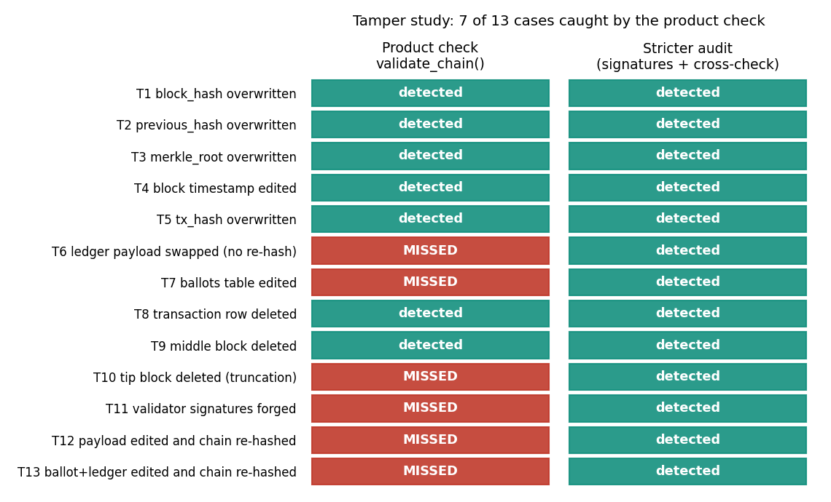
Figure 1: Tamper study: the product check misses edits to the tally table, ledger payloads, signatures and the newest block; the stricter audit catches all of them.
• The auditor's 'tamper test' button does not validate a modified copy: it overwrites a hash in memory and reports detection from a link comparison. It illustrates the idea; the unit test that edits the real database is the independent check.

3.3 Privacy and secrecy
• The table voter_participation stores the voter id next to the ballot id, so an operator with the database and the encryption key can link a voter to a choice. The ballot is anonymous only in the sense that the ballots table has no voter column.
• All ballots are encrypted under one AES key held by the server (the README speaks of a per-election key; the code generates one key), and the tally decrypts every ballot with it.
• The administrator can read a live tally of an open election; the HTTP check confirmed status 200 for that request, whereas a voter receives 404.

3.4 Security configuration
• No TLS is configured. The session cookie is HttpOnly and SameSite=lax but has no Secure flag, because the app is served over plain HTTP. The batch objective names TLS; it was not achieved.
• Sessions and rate-limit counters are in memory and are lost on restart; the limit of 10 logins per minute is per IP address, so voters behind one shared address would share it.
• Secrets (data/secrets.json, validator and system keys) are plain files; the default SECRET_KEY is a development string unless overridden.
• Election windows are stored, but cast_vote checks the status flag only, not the clock, so voting is controlled by the administrator's status change.

3.5 Testing
• The 17 unit tests and the 25-check HTTP matrix cover the paths we thought of; there was no penetration test, fuzzing, static analysis or independent review.
• Concurrent voting was not tested. Block creation reads the last block and writes the next index, so two simultaneous requests could race on the unique block index; the code has no lock.
• No usability or accessibility study with real voters was done.

3.6 Performance
• The benchmark's "asynchronous" batches run sequentially, so the three batch sizes measure the same thing; the throughput differences (22.5, 37.5 and 22.3 ops/s) are machine noise.
• Timings were taken on a shared PC: the same code ran at 57.7 to 62.2 ops/s on an idle machine and 22.3 ops/s during the 1000-voter run.
• validate_chain is linear in chain length (146 ms at 301 blocks) and the stricter audit is slower (788 ms at 361 blocks), so a national chain would need indexing and batching.

3.7 Gaps against the batch abstract and the base paper
The batch abstract promises authentication, verification, election management, vote storage and automatic results; these exist. It also lists password hashing, role-based access control, input validation, audit logging and TLS as security techniques; all but TLS exist, and the abstract's bcrypt was replaced by Argon2id. The base paper's central feature, decentralised verification by Ethereum nodes, has no counterpart in this prototype: the validators are loop iterations in one process. The base paper's biometric authentication is replaced by a number check, which proves less about the person. The prototype therefore implements the application layers of the base paper's four-tier model (storage, web application, client) and a faithful miniature of its ledger rules, but not the distribution that gives a blockchain its trust property [1].
Two smaller defects were found while reading the code and are reported rather than hidden: the README speaks of a per-election encryption key whereas the code uses one key for all elections, and the benchmark documentation calls the batch mode asynchronous whereas the code processes batches in sequence. Neither affects the correctness of a vote, but both would mislead a reader who relied on the description.

4. WHAT WAS NOT MEASURED
Several things a reader might expect were not measured. We list them so that no result is read as covering them.
• Concurrency. No test submitted votes from parallel clients; the sequential benchmark and the one-at-a-time HTTP run say nothing about contention on the ledger.
• Large scale. The largest run had 1000 voters and the largest chain 361 blocks in the study and about 4000 blocks in the 1000-voter benchmark database; nothing was run at the scale of a state election.
• Network behaviour. All traffic was to 127.0.0.1; latency over a real network, packet loss and TLS handshake cost are unknown.
• Memory and disk. CPU time was recorded; resident memory, database growth per vote and disk use were not.
• Real identity data. No test used a real Aadhaar number or UIDAI response, which would be unlawful and unnecessary for a prototype.
• Human factors. No voter or administrator was observed using the interface, so error rates and satisfaction are unknown.
• Base-paper replication. The Oman model was not rebuilt; its per-transaction times were read by eye from Figures 6 and 9 and are quoted only as an order of magnitude.
• Security assurance. No penetration test, code audit or formal analysis was performed beyond the automated checks listed in Chapter 7.
The reasons are mostly practical. The work was done on one shared student PC with no second machine, no access to a real identity service and no real voters; a concurrency test needs a multi-threaded server and a database that supports it, and a usability study needs participants and ethical approval. None of these omissions changes the numbers that were measured, but each limits what they can be taken to mean.

